UNIT-5
EXPERIMENT 1

AIM: To implement exception handling in C++ using try, catch, and throw for handling runtime errors.
DESCRIPTION:
Exception handling in C++ is a powerful mechanism used to manage runtime errors and ensure smooth execution of a program. Instead of allowing the program to crash when an unexpected situation occurs, C++ provides a structured way to detect and handle such errors using the try, throw, and catch keywords. The try block contains the code that might generate an error during execution. If an error is detected, the throw statement is used to signal the occurrence of that error by passing an exception. This exception is then received and handled by the catch block, which contains the code to respond to the error, such as displaying an appropriate message to the user. By using exception handling, programmers can prevent abnormal program termination and maintain control over error situations, making the software more reliable and user-friendly.
PROGRAM:
#include <iostream>
#include <stdexcept> // Needed for runtime_error
using namespace std;

int main() {
int numerator, denominator;

cout << "Enter numerator: ";
cin >> numerator;

cout << "Enter denominator: ";
cin >> denominator;

try {
if (denominator == 0) {
throw runtime_error("Division by zero is not allowed!");
}

double result = static_cast<double>(numerator) / denominator;
cout << "Result = " << result << endl;
}
catch (const runtime_error &e) {
cout << "Exception caught: " << e.what() << endl;
}

cout << "Program continues after exception handling..." << endl;

return 0;
}
OUTPUT:
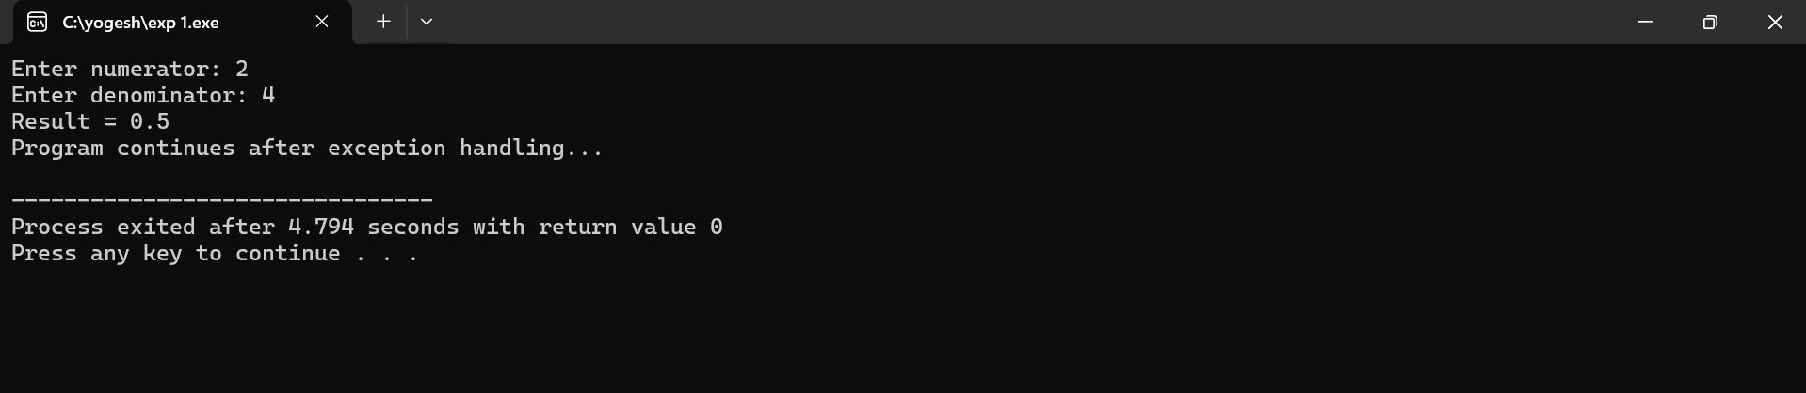
RESULT:
The program successfully handles runtime errors without crashing by displaying an appropriate error message when an exception occurs. It ensures smooth continuation of execution even after encountering invalid operations like division by zero.

EXPERIMENT 2
AIM: To write a C++ program that demonstrates the use of multiple catch statements for handling different types of exceptions.
DESCRIPTION:
In C++, multiple catch statements are used to handle different types of exceptions separately within the same try block. When an error occurs and an exception is thrown, the program checks each catch block in order to find a matching data type for the thrown exception. This allows specific handling for different error types, such as integer errors, character errors, or string messages. By using multiple catch statements, the program becomes more flexible and can respond appropriately based on the nature of the error, rather than using a single generic error message.
PROGRAM:
#include <iostream>
using namespace std;
int main() {
try {
int choice;
cout << "Enter 1 for int exception, 2 for float exception, 3 for string exception: ";
cin >> choice;

if (choice == 1)
throw 10; // Integer exception
else if (choice == 2)
throw 3.14f; // Float exception
else if (choice == 3)
throw "Hello"; // String exception
else
throw 'X'; // Character exception
}

catch (int e) {

cout << "Caught an integer exception: " << e << endl;

}
catch (float e) {
cout << "Caught a float exception: " << e << endl;

}
catch (const char* e) {
cout << "Caught a string exception: " << e << endl;

}
catch (...) {
cout << "Caught an unknown exception!" << endl;

}
cout << "Program continues after exception handling." << endl;
return 0;
}
OUTPUT:
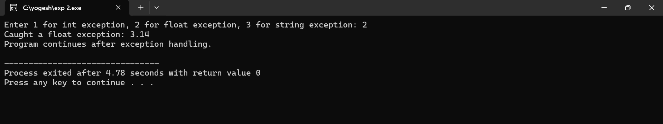
RESULT:
The program successfully identifies and handles each exception according to its data type using separate catch blocks. It ensures that different errors receive appropriate messages instead of a single generic response.

EXPERIMENT 3
AIM: Program to implement List, Vector and perform basic operations using the STL (Standard Template Library) in C++.
DESCRIPTION:
- std::vector: A dynamic array that allows random access and is efficient for insertions/removals at the end.
- std::list: A doubly linked list that allows efficient insertions/removals from anywhere in the list but does not support random access.
This program:
- Creates a vector and a list of integers.
- Performs insertion, deletion, sorting, and traversal.
- Demonstrates the differences in usage and performance characteristics.
PROGRAM:
#include <iostream>
#include <vector>
#include <list>
using namespace std;

int main() {
// Vector operations
vector<int> v;
v.push_back(10);
v.push_back(20);
v.push_back(30);
cout << "Vector elements: ";
for (int i = 0; i < v.size(); i++)
cout << v[i] << " ";
cout << "\nSize: " << v.size() << ", Capacity: " << v.capacity() << endl;

v.pop_back();
cout << "After pop_back, Vector elements: ";
for (auto it = v.begin(); it != v.end(); ++it)
cout << *it << " ";
cout << endl;

// List operations
list<int> l;
l.push_back(100);
l.push_front(50);
l.push_back(150);
cout << "\nList elements: ";
for (auto it = l.begin(); it != l.end(); ++it)
cout << *it << " ";
l.remove(100); // Remove element
cout << "\nAfter removing 100, List elements: ";
for (int x : l)
cout << x << " ";
cout << endl;
return 0;
}
OUTPUT:
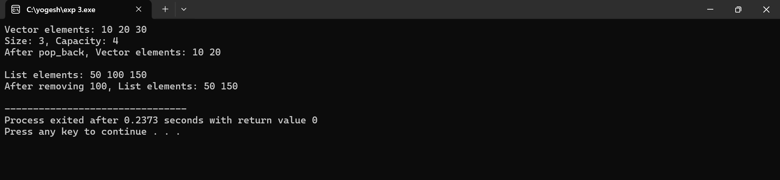
RESULT:
The program successfully performs insertion, deletion, and traversal operations using both vector and list from the STL. It shows how STL containers simplify data handling with built-in functions and iterators.
EXPERIMENT 4
AIM: To write a C++ program to implement a Deque (Double-Ended Queue) and perform various operations such as insertion and deletion from both ends.
DESCRIPTION:
A Deque (Double-Ended Queue) in C++ is a dynamic data structure that allows insertion and deletion of elements from both the front and the rear ends. It can be efficiently implemented using the deque container from the Standard Template Library (STL). By using functions like push_front(), push_back(), pop_front(), and pop_back(), various operations can be performed easily without manually handling memory. Deques provide flexibility similar to both stacks and queues, making them useful in situations where data needs to be accessed or modified from either side.
PROGRAM:
#include <iostream>
#include <deque>
using namespace std;

int main() {
deque<int> dq;

// Insert elements
dq.push_back(10); // Insert at rear
dq.push_back(20);
dq.push_front(5); // Insert at front
cout << "Deque elements: ";
for (int x : dq) {
cout << x << " ";
}
cout << endl;

// Access elements
cout << "Front element: " << dq.front() << endl;
cout << "Back element: " << dq.back() << endl;

// Deletion
dq.pop_front(); // Remove front element
dq.pop_back(); // Remove rear element
cout << "Deque after deletion: ";
for (int x : dq) {
cout << x << " ";
}
cout << endl;
// Insert more elements
dq.push_front(100);
dq.push_back(200);
cout << "Deque final state: ";
for (int x : dq) {
cout << x << " ";
}
cout << endl;
return 0;
}
OUTPUT:
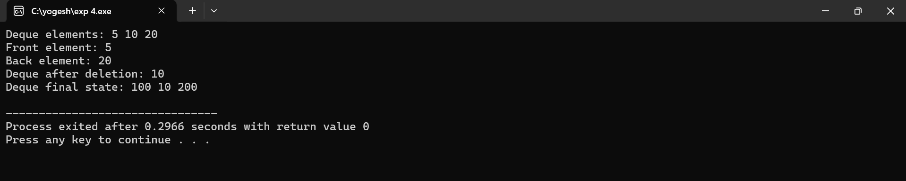
RESULT:
The program successfully inserts and deletes elements from both the front and rear ends of the deque. It demonstrates that the STL deque container provides efficient and convenient operations for double-ended data handling.
EXPERIMENT 5
AIM: To write a C++ program that demonstrates the implementation of a map container and performs various operations such as insertion, traversal, search, deletion, and size check.
DESCRIPTION:
A map in C++ is an associative container from the Standard Template Library (STL) that stores elements in key-value pairs, where each key is unique and automatically sorted. It is typically implemented using a balanced binary search tree, which ensures efficient insertion, searching, and deletion operations. By using member functions such as insert(), find(), erase(), and size(), different operations can be performed easily. Iterators are used for traversing the map and displaying all key-value pairs. Maps are widely used when fast lookup and organized storage of paired data are required.
PROGRAM:
#include <iostream>
#include <map>
#include <string>
using namespace std;

int main() {
// Declare a map with key as int and value as string
map<int, string> student;
// Insertion
student[1] = "Alice";
student[2] = "Bob";
student.insert({3, "Charlie"});
student.insert({4, "David"});
cout << "Map Elements (Key -> Value):" << endl;
for (auto it = student.begin(); it != student.end(); ++it) {
cout << it->first << " -> " << it->second << endl;
}

// Searching an element
int key = 3;
auto it = student.find(key);
if (it != student.end()) {
cout << "\nFound: " << it->first << " -> " << it->second << endl;
} else {
cout << "\nKey " << key << " not found." << endl;
}

// Deleting an element
student.erase(2);
cout << "\nAfter deleting key 2:" << endl;
for (auto &pair : student) {
cout << pair.first << " -> " << pair.second << endl;
}
// Size of the map
cout << "\nSize of the map: " << student.size() << endl;
return 0;
}
OUTPUT:
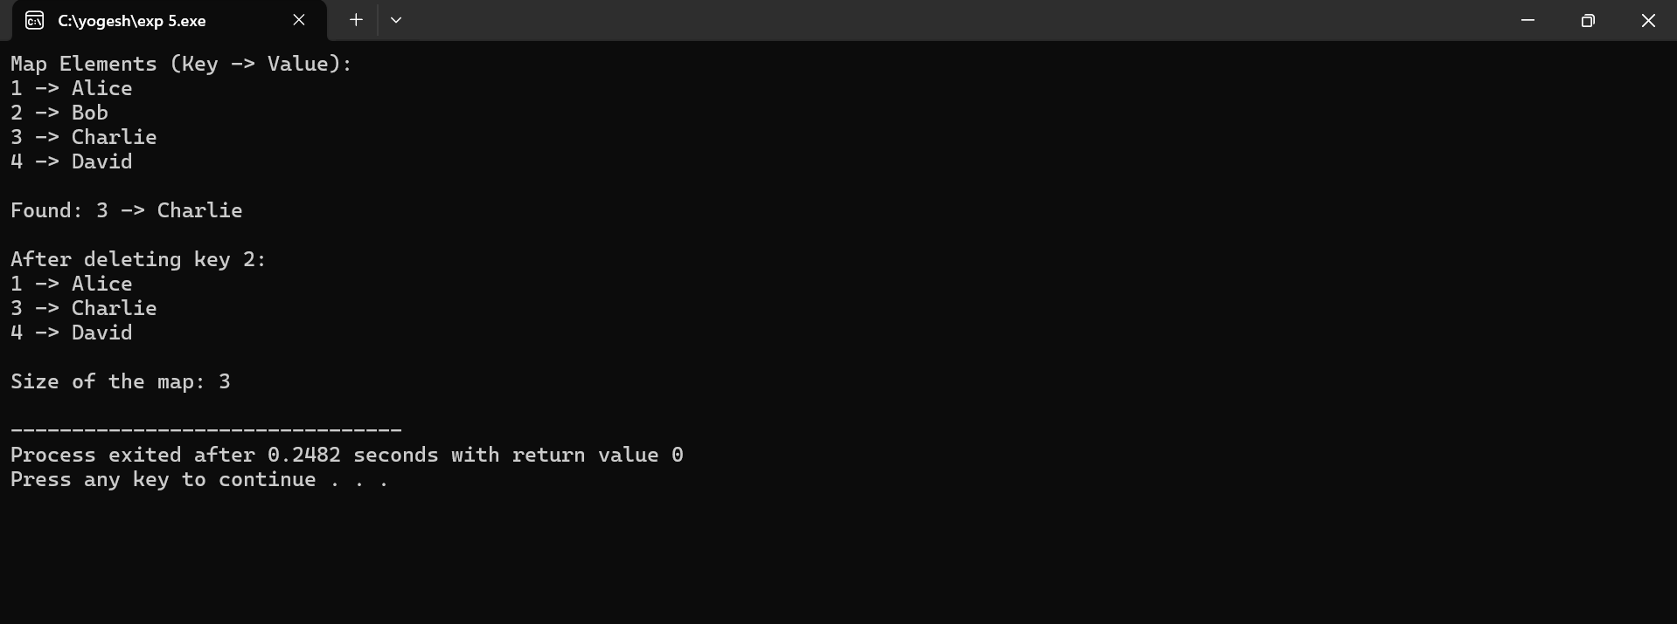

RESULT:
The program successfully demonstrates insertion, traversal, searching, deletion, and size checking using the map container. It confirms that the map efficiently handles key-value based data management with built-in STL functions.

